Subject: Algebra – Math A
Benchmark: Hatshepsut’s Temple
Standards: 1A1, 3E
TOPIC: Trigonometric Ratios

MAJOR IDEA:
- In a right triangle with sides a, b, and hypotenuse c, with corresponding angles A, B, and C:
  - The sine of angle A equals a/c (opposite over hypotenuse). sin A = a/c.
  - The cosine of angle A equals b/c (adjacent over hypotenuse). cos C = b/c.
  - The tangent of angle A equals a/b (opposite over adjacent). tan A = a/b

SUGGESTED AIMS:
- What do the terms sine, cosine, and tangent represent and what ratios they correspond to in a right triangle?
- How do you calculate the length of a side of a right triangle given another side and an angle?
- How do you apply trigonometric ratios to real world situations involving triangles, such as angle of elevation problems?

VISUAL EXAMPLES:
- Exterior view of the Temple of Hatshepsut.

SUGGESTED ACTIVITIES:
- Provide the students with a mnemonic device to remember the ratios, such as “SOH CAH TOA” (where S, C, and T represent sine, cosine, and tangent, and O, A, and H represent opposite, adjacent, and hypotenuse).
- Using the 30°, 60°, 90° triangles below, students may find sin 60°, cos 60°,
tan 60°, cos 30°, sin 30°, and tan 30°.
1

2

√3
30°

- What is the length of side x?

- You are visiting the Hatshepsut Temple at Deir El-Bahri and are about to walk up the first ramp. You want to know how far it is to the top of the ramp. Looking at the diagrams below and the Section of the Hatshepsut Temple on the following page, apply trigonometric rations to first find the height a of the ramp and then its length c.

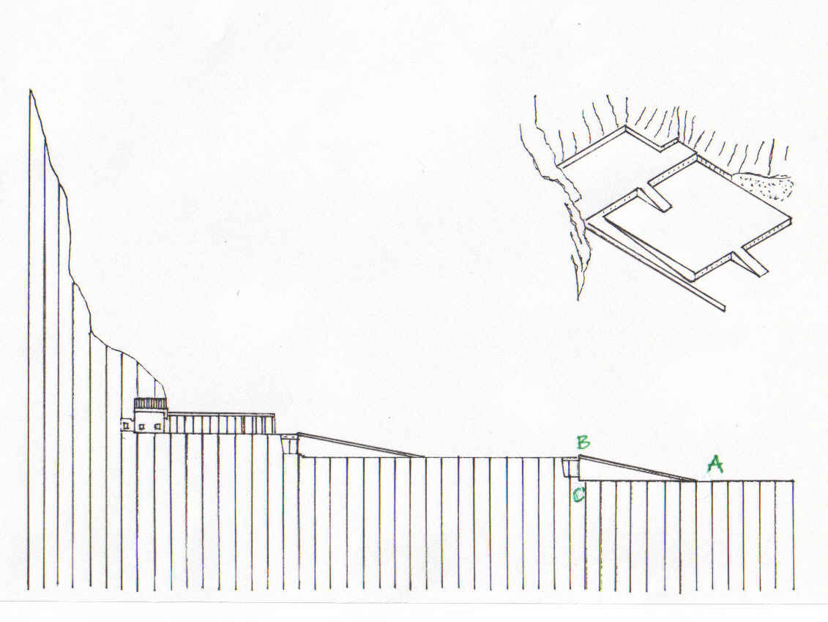
Section of the Hatshepsut Temple

- Ancient Egyptian mathematicians were familiar with trigonometric ratios and Pythagorean triples. They often used 3-4-5 right triangles in their architecture. What are the angle measurements of a 3-4-5 triangle?

RESOURCES:
- http://www.touregypt.net/featurestories/numbers.htm. This page discusses ancient Egyptian mathematics, with some specific references to trigonometry. It also contain examples of the kinds of questions ancient Egyptian math students were asked during their studies.
- http://www.ehabweb.net/hatshebsut_temple.html. Many views of the Hatshepsut temple.

HOMEWORK:
  - Students should attempt to calculate the height of their house by using a wooden compass with protractor markings to measure the angle of elevation from their eyes to the top of the house. They should also measure how far away they are from the top of the house. The tangent ratio can then be used to calculate the height of the house. Students must remember to compensate for the height of their eyes above the ground, as well as making sure they are measuring the horizontal distance from themselves to the top of the house, not just to the front.

- Angle of Elevation:

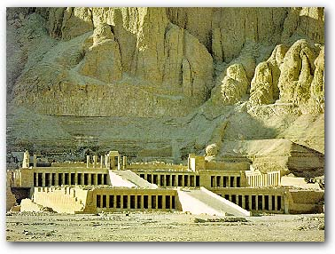Exterior View of Hatshepsut’s Temple
14°

